1. We first made a new function to get the products by slug in the actions

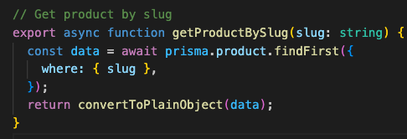

1. Then we made a new product – slug file-based routing in the root

1. Then we tested the function with next js 15 new params method.

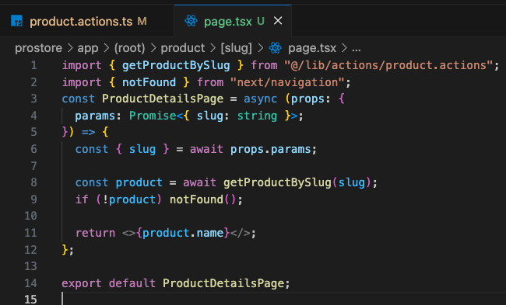

1. Now we start making the design. So, we install the badge component



1. And we constructed the whole product detail page

